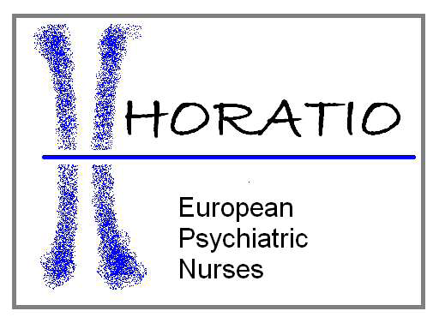

Horatio Fellowship Award

As announced at the Annual General Meeting in May 2017, the Horatio Award will recognise recipients for their contribution to the professional activities in support of psychiatric/mental health nursing (PMHN), either in Europe or worldwide. It is designed to ensure that those who have had an extraordinary influence on the professional growth, development, and identity of PHMN will be rewarded for their endeavours. The first to receive the award in 2017 was Mr. Des Kavanagh who, throughout a long and active career, had been highly influential representing PMHN in Ireland, and for nine years was the first President of Horatio. In 2018 Mr. Michael Schulz received the award acknowledging his contribution to the profession in Psychiatric Nursing / Mental Health Education and Research and in his home country Germany and as a board member of Horatio.

Award Process
NB Only full, paid up, member organisations of Horatio can nominate one person per year using the attached form. It can either be one of their own nationals, or someone they wish to recognise from another country. Nominations are not restricted to European nurses only but may be from worldwide. There are no specific criteria that need to be met, but the individual must have demonstrated over time a commitment to their own work and that of PMHN. Nominations should be sent to the General Secretary of Horatio by the closing date on the form. All nominations must be accompanied by the signed Nominee Consent Form.

Award Selection
The recipient will be the individual who, in the opinion of the Board members, has demonstrated the qualities necessary to receive this prestigious award. In the event that the Board is unable to agree upon a successful candidate, more than one Fellowship may be awarded for that year, though this is to be avoided if possible. In the event that the Board does not feel that the nominations meet with the high standard set for the award, no Fellowship will be offered that year. Nominating organisations will be advised of the Board’s decisions in advance of the award presentation.

Award Presentation
The award will be announced and presented at the next Horatio Congress or Festival. Whilst it is preferable, the recipient does not have to be present at the event. In the case of an absent recipient a nominated person/organisational representative, may receive the award on their behalf. The Fellowship is awarded for life and the Fellow’s name will appear on the Horatio website, along with the announcement of their award and short biographical details about the individual. (In very extreme circumstances, and at the discretion of the Horatio Board, a Fellowship may be withdrawn).

Fellowship Nomination form

Name of Nominee
Consent form attached? | Yes  No
Nationality
Contact details
 | Nomination details
Why does your organisation feel this individual should receive the Fellowship Award?
(Max 400 words)

Member Organisation
Name of signatory
Role within the organisation (i.e. President)

Nominations must be received by the Horatio General Secretary at info@horatio-web.eu no later than t4 weeks in advance of the upcoming Horatio Congress or Festival 6.2.2023

Horatio Fellowship Award

Nominee Consent Form

Name of Nominee

Nominating Organisation

Dear

Your name has been put forward as a nominee for the annual Horatio Fellowship award which recognises outstanding work in support of psychiatric and mental health nurses in Europe and/or worldwide. In order that your nomination can be submitted you are kindly requested to sign below giving your consent to be nominated

I __________________________________________________, hereby give my permission to be nominated for the Horatio Fellowship Award

Signed _______________________________________________

